

Department of Computer Science

Lab Manual of

MACHINE LEARNING

MCA521-4

Class Name: IV MCA Master of Computer Application
2026

Prepared by: Verified by:

Nirupama Vincent 2547236  4MCAB | Dr. Rupali Sunil Wagh Dr. Helen K Joy  Dr. Shivangi Singh

Department Overview
Department of Computer Science of CHRIST (Deemed to be University) strives to shape outstanding computer professionals with ethical and human values to reshape nation’s destiny. The training imparted aims to prepare young minds for the challenging opportunities in the IT industry with a global awareness rooted in the Indian soil, nourished and supported by experts in the field.

Vision
The Department of Computer Science endeavours to imbibe the vision of the University
“Excellence and Service”. The department is committed to this philosophy which pervades every aspect and functioning of the department.

Mission
“To develop IT professionals with ethical and human values”. To accomplish our mission, the department encourages students to apply their acquired knowledge and skills towards professional achievements in their career. The department also moulds the students to be socially responsible and ethically sound.

Introduction to the Programme
Master of Computer Applications (MCA) is a post-graduate programme of CHRIST (Deemed to be University) and approved by the All India Council of Technical Education (AICTE). It is a two-year programme spread over six trimesters to bridge the chasm between computer studies and applications, bringing within reach of enthusiastic youngsters an excellent group of experienced and dedicated staff and experts, and an enviable infrastructure. MCA at CHRIST (Deemed to be University) strives to shape outstanding computer professionals with ethical and human values to reshape the nation’s destiny. The training programme aims to prepare young minds for challenging opportunities in the IT industry with a global awareness rooted in the Indian soil, nourished and supported by
experts in the field. The Department is committed to the motto “Excellence and Service,” and this philosophy pervades every aspect of its functioning.

Programme Objective
This programme is conceptualised and designed based on the strong commitment of the department to provide better quality education to the students. The principal objectives of this course are to:
- Heighten technological awareness
- Train future industry specialists
- Encourage effective software development
- Provide research training
- Involve students in innovative research
- Produce graduates with a two-year professional education in Computer Science with technical, professional, and communications skills.
Ethics and Human Values

- Only proprietary or open-source software would be used for academic teaching and learning purposes.
- Copying of programs from the internet, friends or from other sources is strictly discouraged since it impairs development of programming skills.
- Unique Practical (Domain based) exercises ensure that the students don’t get involved in code plagiarism.
- Projects undertaken by students during the course are done in teams to improve collaborative work and synergy between team members.
- Projects involve modularization which initiates students to take individual responsibility for common goals.
- Passion for excellence is promoted among the students, be it in software development or project documentation.
- Giving due credit to sources during the seminar and research assignment is promoted among the students
- The course and its design enforce the practice of good referencing technique to improve the sense of integrity.
- Courses involving group discussions and debates on ethical practices and human values are designed to sensitize the students in dealing with customers and members within the Organization.

Programme Outcomes:
P01: Foundation Knowledge: Apply knowledge of mathematics, programming logic, and coding fundamentals for solution architecture and problem-solving.
P02: Problem Analysis: Identify, review, formulate, and analyse problems primarily focussing on customer requirements using critical thinking frameworks.
P03: Development of Solutions: Design, develop and investigate problems with as an innovative approach for solutions incorporating ESG/SDG goals.
PO4: Modern Tool Usage: Select, adapt, and apply modern computational tools such as the development of algorithms with an understanding of the limitations including human biases. P05: Individual and Teamwork: Function and communicate effectively as an individual or a team leader in diverse and multidisciplinary groups. Use methodologies such as agile.
P06: Project Management and Finance: Use the principles of project management such as scheduling, and work breakdown structure and be conversant with the principles of Finance for profitable project management.
P07: Ethics: Commit to professional ethics in managing software projects with financial aspects.
Learn to use new technologies for cyber security and insulate customers from malware P08: Life-long learning: Change management skills and the ability to learn, keep up with contemporary technologies and ways of working.

Programme Educational Objectives(PEO’s)
PEO1: Develop innovative and effective software solutions through research that addresses real-world challenges, grounded in a commitment to continuous learning and adaptability. PEO2: Advance the knowledge and practices in the field of computer applications through lifelong learning and rigorous research, supporting professional growth and academic excellence.
PEO3: Exhibit ethical leadership, social responsibility to contribute and enhance community well-being by innovating solutions.

MCA521-4 – MACHINE LEARNING
Course Name: MACHINE LEARNING Code: MCA521-4
Total Hours: 75
L + P + T: 3 + 4 + 0
Max Marks: 100
Credits: 4
Course Type: Core Course Course Category: Theo&Prac Course Description
Machine Learning is a key area in computer applications that focuses on building models capable of making predictions or informed decisions based on data. A strong understanding of machine learning enables students to analyze and interpret complex datasets, develop predictive models, and extract meaningful insights. This course covers a wide range of machine learning concepts and techniques, including supervised and unsupervised learning. It provides a solid theoretical foundation while emphasizing practical, hands-on experience with algorithms and real-world data. The course equips students with the knowledge and skills required to apply machine learning techniques across various domains using modern tools and methodologies.
Course Objectives
This course enables students to understand the fundamental concepts of Machine Learning, including its core principles, terminology, and methodologies. Students will learn to differentiate between various types of learning algorithms such as supervised, unsupervised, and reinforcement learning, and recognize their appropriate applications.
Course Outcomes
After successful completion of the course, students will be able to:
- Explain the fundamental principles and scope of Machine Learning
- Implement modelling practices in machine learning for better generalisation
- Interpret predictive modelling results and performance of supervised machine learning techniques
- Assess the outcomes and effects of unsupervised machine learning processes
- Deploy robust machine learning models for interdisciplinary applications

Unit-1: INTRODUCTION TO MACHINE LEARNING Teaching Hours: 15 Hours
Introduction to AI – Knowledge Representation – Data – Representation of Data, Data Processing, Data Storage, Data Processing, Types of Data – Exploratory Data Analysis, Visualisations and Interpretation, Outliers
Machine Learning: Definition, Objectives, Components, Features, Applications – Traditional Programming v/s Machine Learning, Types of Machine Learning – Predictive Models, Statistical Inferences – Applications of Machine Learning
Challenges in ML: Insufficient Quantity of Data, Non-representative and Poor-Quality Data, Irrelevant Features, Estimation Estimation, Reducing Human Biases in Model Building, Ethical Use of Technology
Lab Exercises:
- Data Preprocessing and visualisation
- Data exploration and inferences

Unit-2: PROCESSES IN MACHINE LEARNING Teaching Hours: 15 Hours

Data Preparation and Model Selection: Effect of Data Preparation: Encoding, Nominal and Ordinal Representation, Feature Transformation and Feature Engineering, Generalisation, Normalisation, Sampling, Using Saved Weights, Model Selection Strategies: Overfitting, Underfitting, Bias-Variance Trade-off, Testing and Validation: Performance measures - Confusion matrix, Precision-Recall Trade off, F1 Score, ROC Curve, AUC, Error Analysis, Model Parameters, Hyperparameters, Hyperparameter Tuning, Cross Validation, Decision Functions: Introduction to Supervised Machine Learning Methods, Decision Functions, Decision Thresholds, Distance Measures, Hyperplanes, Regression & Classification Problems, Loss and Cost Functions, Linear Regression using OLS, Multi-class vs Multi-label, KNN Classification
Lab Exercises:
- Saving weights of a generalised model.
- Regression and Classification Evaluation Metrics: Illustration through Linear Regression and KNN Classification

Unit-3: SUPERVISED LEARNING ALGORITHMS Teaching Hours: 15
Hours
Learning through Optimisation: Gradient Descent, Linear Regression, Logistic Regression Computational Learning: Decision Trees, Naive-bayes classification, Support Vector Machines, Ensemble Learners: Learning, Voting, Bagging, Stacking, Boosting, Random Forests, GridSearchCV Lab Exercises:

- Regression through Gradient Descent
- Comparison of Different Classifiers
- Illustration of Ensemble Learning Methods

Unit-4: UNSUPERVISED LEARNING AND DIMENSIONALITY REDUCTION Teaching
Hours: 15 Hours
Introduction: Types of Unsupervised Learning, Challenges in Unsupervised Learning, Concept of Cost Functions in Unsupervised Learning, Clustering Methods: Distance based, Centroid Based, Elbow method to find Optimal Number of Clusters, Silhouette Method, K-Means Clustering, Hierarchical Clustering: Agglomerative and Bottom Up, Applying Supervised Learning after Clustering, Dimensionality Reduction Methods: Principal Component Analysis (PCA), Linear Discriminant Analysis (LDA)
Lab Exercises:
- KMeans and Elbow Methods
- Hierarchical Clustering and Dendrograms
- Dimensionality Reduction
- Image Compression using Dimensionality Reduction.

Unit-5 Teaching Hours: 15 Hours MACHINE LEARNING IN REAL-WORLD
Emerging Techniques: Role of ML in attaining Sustainable Development Goals, Time Series Preprocessing, Blackbox Methods: Neural Networks & Deep Learning, Reinforcement Learning/QLearning, Self Supervised Learning, Quantum Machine Learning, Keras and Tensorflow for

designing Multi Layer Perceptron. Case Studies: CNN, RNN, Advances in Deep Learning, Natural Language Processing, Real Time Systems, Computer Vision, Robotics, Expert Systems, Generative Networks, Large Language Models. Model Deployment: Model Deployment: Connecting Models to User Interface, Deployment of ML Models.
Lab Exercises:
- Training a Multi-layer perceptron
- Deploying Trained ML-models

Text and Reference Books
- Campesato, O. (2020). Artificial Intelligence, Machine Learning and Deep Learning. Mercury Learning and Information.
- Andreas C. Müller and Sarah Guido (2017), “Introduction to Machine Learning with Python A Guide For Data Scientists” O’Reilly book
- Ethem Alpaydin (2005), “Introduction to Machine Learning”, Prentice Hall of India
- Max Kuhn and Kjell Johnson (2018), “Applied Predictive Modelling”, Springer

Essential Reading
- Stuart Russell and Peter Norvig(2020), “Artificial Intelligence: A Modern Approach” (4th Edition), Pearson
- Aurelien Geron(2019), “Hands on Machine Learning with Scikit-learn, Keras and Tensorflow”, 2nd Edition, O’Reilly Books
- Kevin P. Murphy(2012), “Machine Learning: A Probabilistic Perspective”, MIT Press
- Hastie, Tibshirani, Friedman(2008), “The Elements of Statistical Learning” (2nd ed), Springer
- Ian Goodfellow, Aaron Courville, Yoshua Bengio (2019), “Deep Learning (Adaptive Computation And Machine Learning Series)”, MIT Press
Additional Information (Web Resources):
1. Andrew Ng, Deeplearning.ai, Machine Learning Specialisation, offered through Coursera: https://www.deeplearning.ai/courses/machine-learning-specialization/

Evaluation Pattern: CIA - 50% ESE - 50%

LIST OF PROGRAMS

MSCAIML
Sl. no | Title of lab Experiment | Page number | RB T | CO
1 | India Air Quality & Crop Yield — EDA Lab Data Preprocessing, Visualisation & Exploration |  | L3 | CO1, 3
2 |  |  | L3 | CO2, 3
3 |  |  | L3 | CO3
4 |  |  | L3 | CO3
5 |  |  | L3 | CO3
6 |  |  | L3 | CO3, 4
7 |  |  | L4 | CO3
8 |  |  | L3 | CO3
9 |  |  | L3 | CO4
10 |  |  | L5 | CO4

Evaluation Rubrics:
Evaluation Rubrics for each program would be

Submission Guidelines:

- Make a copy of the lab manual template with your <name_reg:no_subject name >,

- Copy the given question and the answer (lab code) with results, followed by the conclusion of that lab. Title the lab as lab number.
- Keep updating your lab manual and show the lab manual of that particular lab for evaluation.
- Create a Git Repository in your profile <ML lab-reg no> . Follow a different branch for each lab <Lab 1, Lab 2…>, and push the code to Git. The link should be provided in Google Classroom along with the PDF of the lab manual.
- Upload the PDF to Google Classroom before the deadline.

Lab 1 & 2
India Air Quality & Crop Yield - EDA Lab: Data Preprocessing, Visualisation & Exploration

Lab Exercise I & II:

Aim
- To investigate whether worsening air quality across Indian states is linked to declining agricultural output by independently choosing, applying, and justifying appropriate data analysis and visualisation techniques on raw, messy, real-world datasets.

Evaluation Rubrics

Submission Guidelines
- Make a copy of the lab manual template with your <name_reg:no_subject name>
- Copy the given question and the answer (lab code) with results, followed by the conclusion of that lab. Title the lab as Lab 1.
- Keep updating your lab manual and show the lab manual of that particular lab for evaluation.
- Create a Git repository in your profile <ML lab-reg no>. Follow a different branch for each lab <Lab 1, Lab 2 …> and push the code to Git.
- Provide the Git link in Google Classroom along with the PDF of the lab manual.
- Upload the PDF to Google Classroom before the deadline.

Code with Results Task 1
Dataset Profiling and Initial Data Inspection

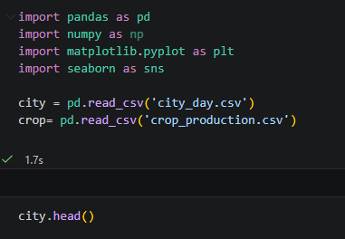
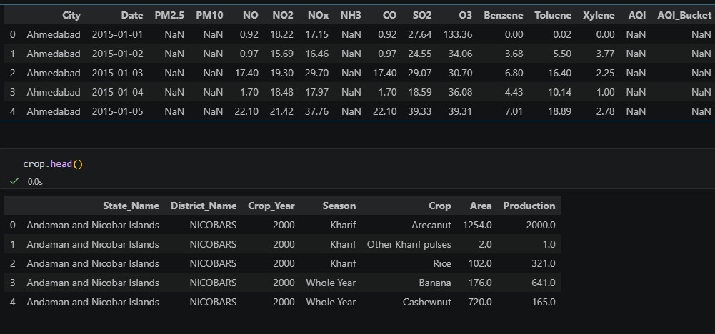
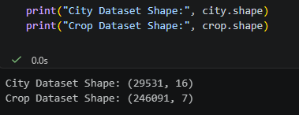

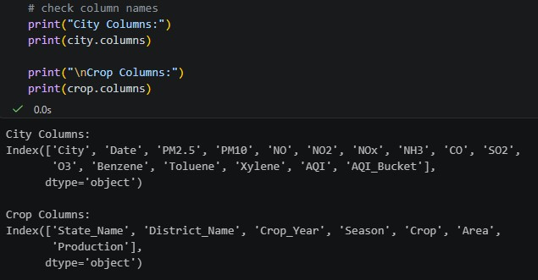
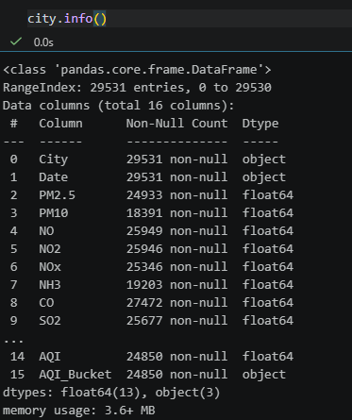

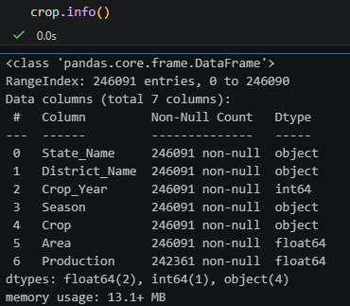
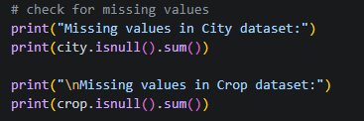
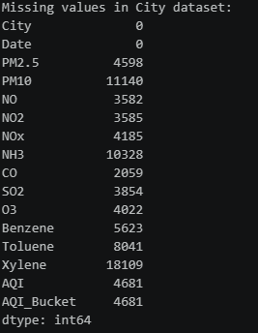
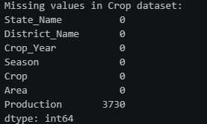

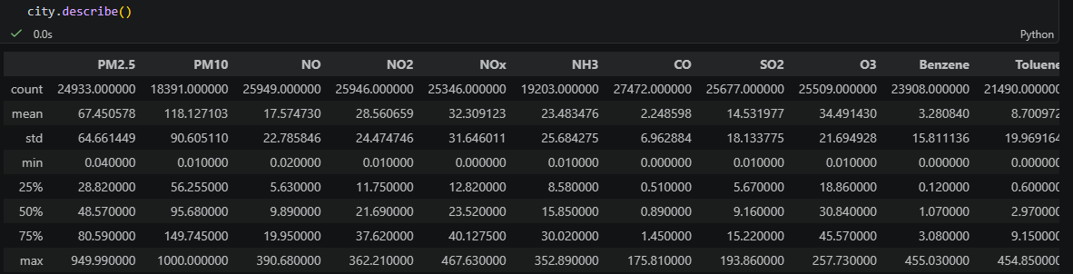
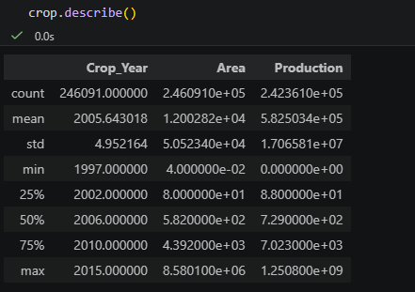
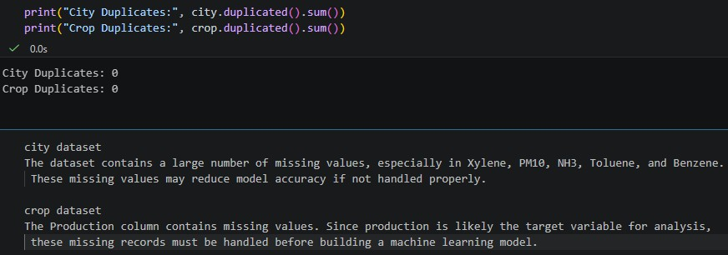

Task 2

Missing Value Analysis and Treatment

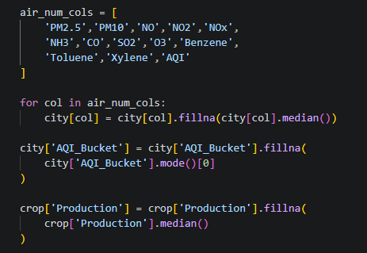
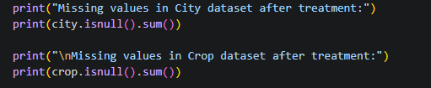
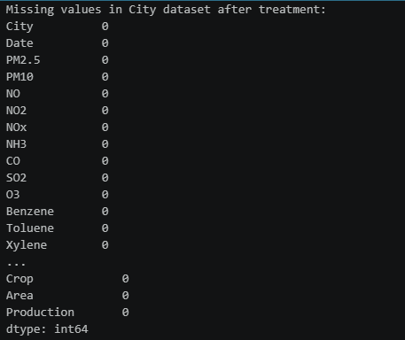

Task 3

State Name Standardization and Duplicate Removal
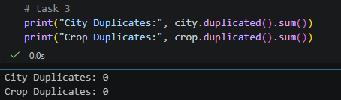
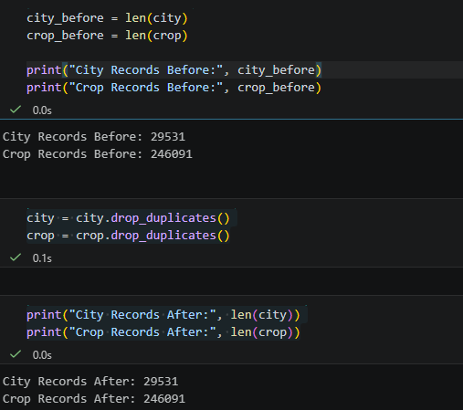

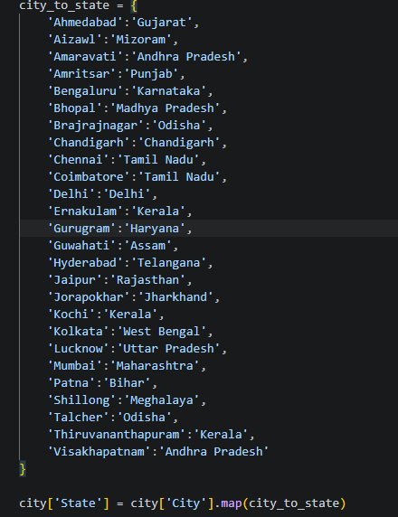
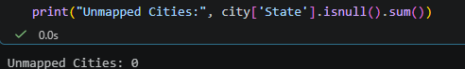
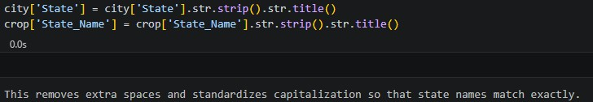

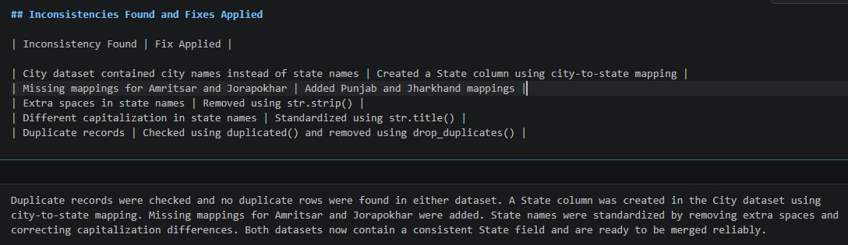

Task 4

AQI Distribution Analysis
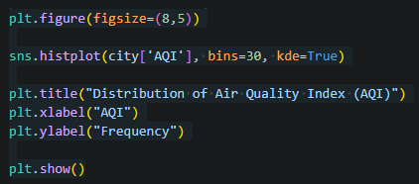
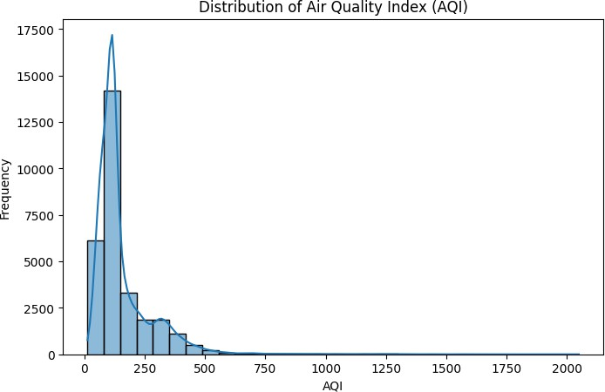

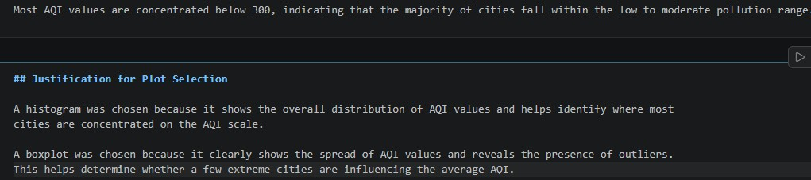
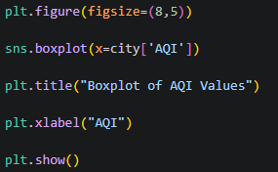
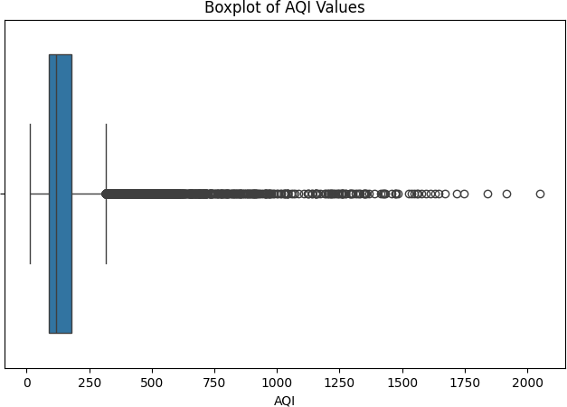

Task 5

Outlier Detection and Treatment in AQI

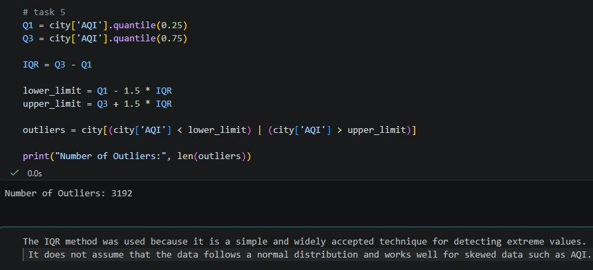
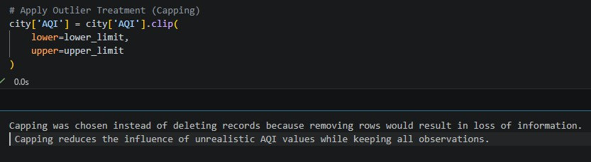
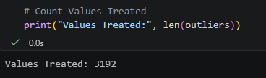
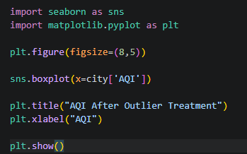

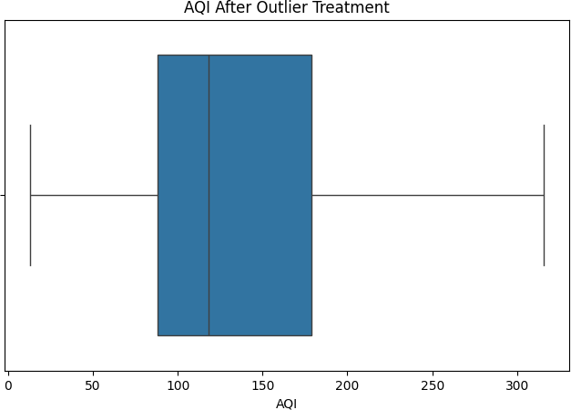

Task 6

Year-wise AQI Trend Analysis

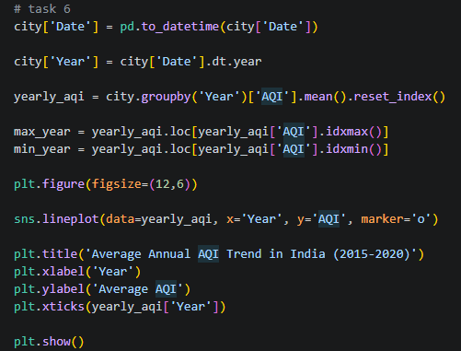

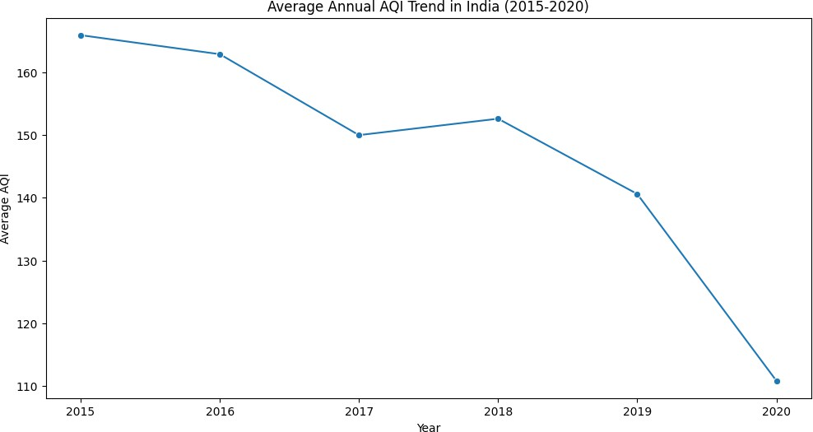
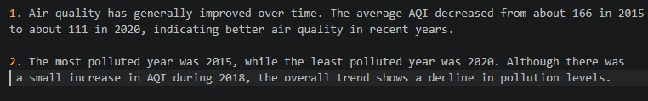

Task 7

Seasonal AQI Pattern Analysis
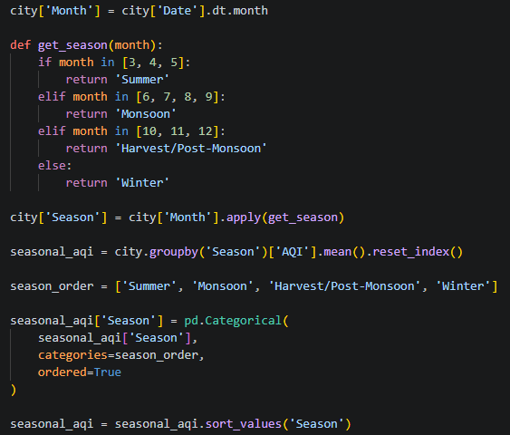

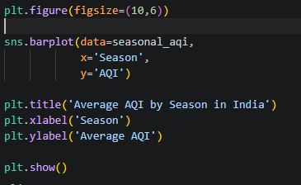
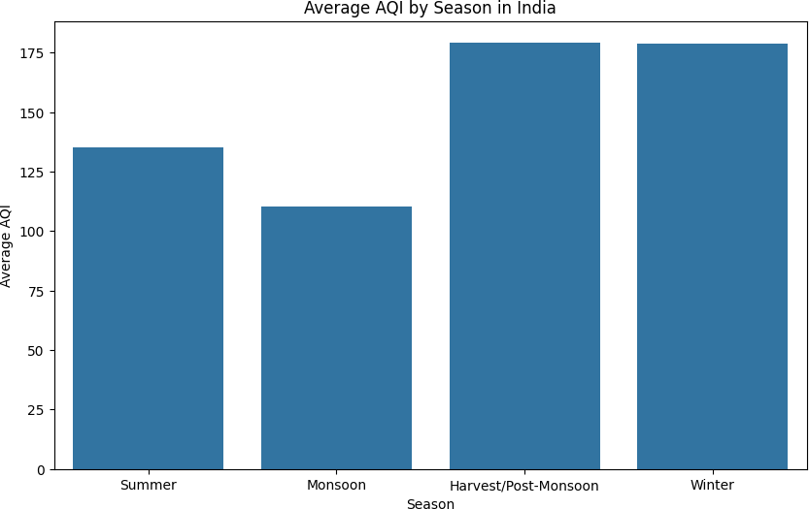
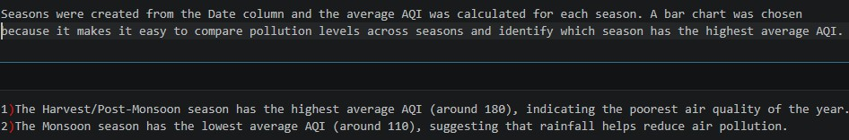

Task 8

Integration of Air Quality and Crop Production Datasets

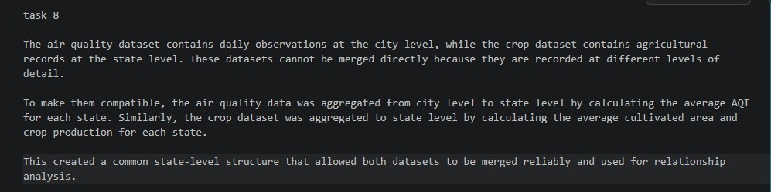
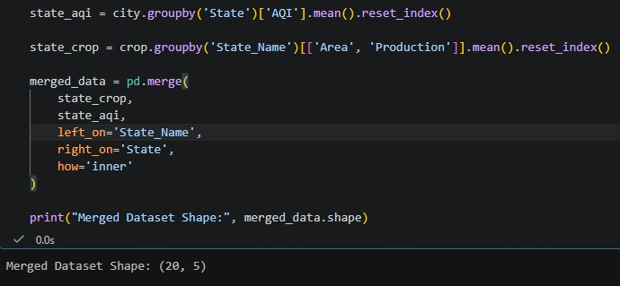
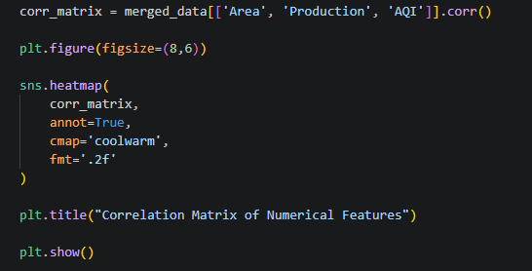

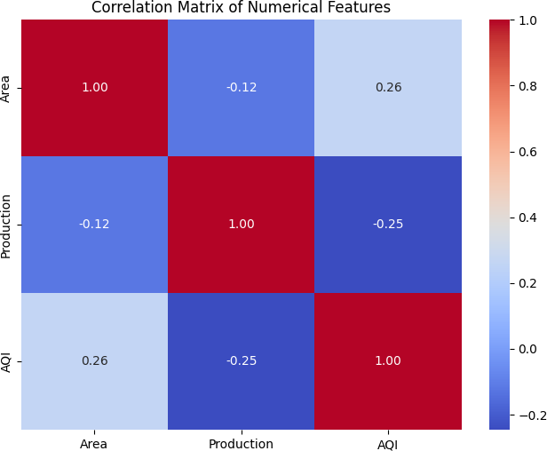
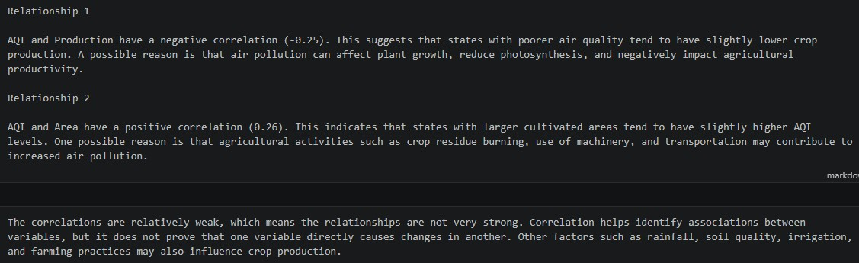

Task 9

Policy Brief for the Environment Minister

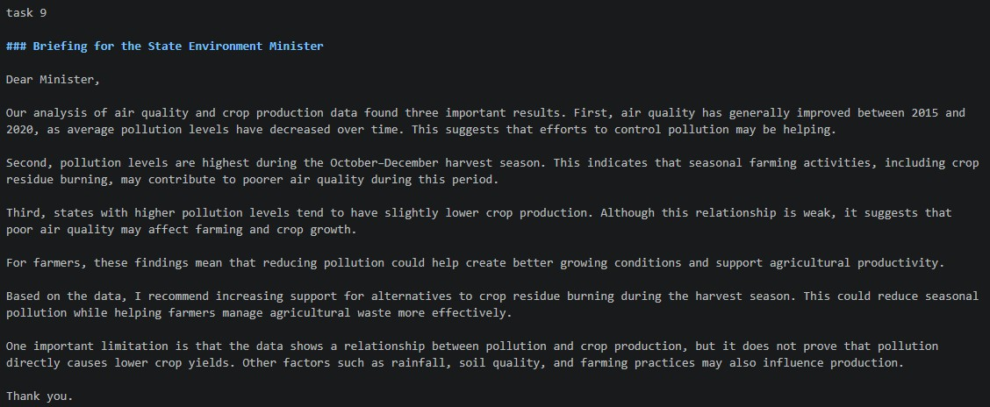
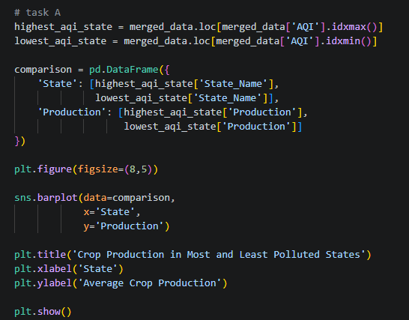
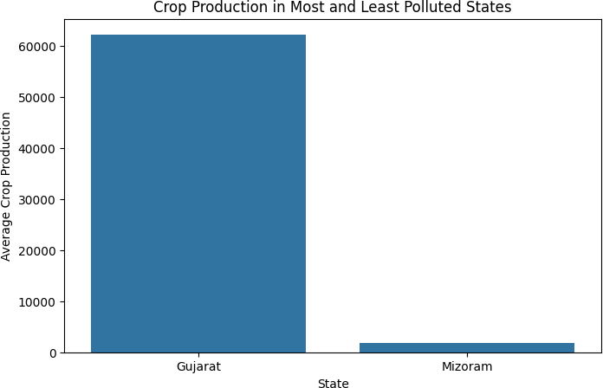

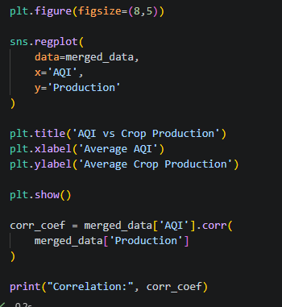
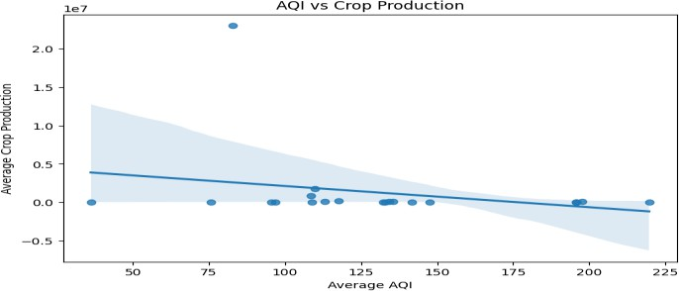
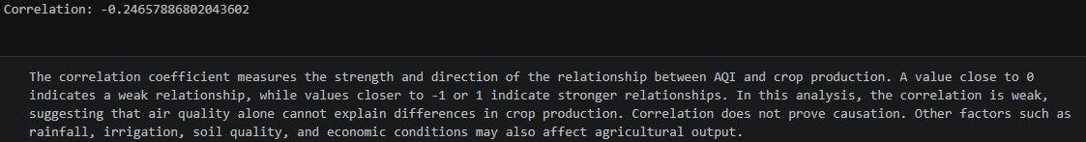

Conclusion /inference

This study examined the relationship between air quality and agricultural production in India using historical AQI and crop production datasets. Data preprocessing revealed missing values, inconsistent state names, and extreme AQI observations, all of which were treated to ensure reliable analysis. Exploratory analysis showed that AQI levels are positively skewed, with a small number of highly polluted observations influencing overall pollution statistics.
Trend analysis indicated a gradual improvement in air quality between 2015 and 2020, while seasonal analysis revealed that pollution levels are highest during the Harvest/Post-Monsoon

season (October–December). This finding supports concerns that seasonal agricultural activities and related emissions may contribute to worsening air quality during this period.
After merging the environmental and agricultural datasets at the state level, a weak negative correlation (r ≈ -0.25) was observed between AQI and crop production. Although states with poorer air quality tended to have slightly lower agricultural output, the relationship was not strong enough to conclude that pollution directly causes reduced crop yields. Other important factors such as rainfall, irrigation, soil quality, crop variety, farming practices, and economic conditions were not included in the dataset and may have a greater influence on production levels.
Overall, the analysis suggests that air pollution remains a significant environmental challenge and may be associated with agricultural performance. However, the evidence is correlational rather than causal. Further research using additional climatic, environmental, and agricultural variables would be required to determine the true impact of air quality on crop productivity.

Lab 3
Student Survey: Simple Linear Regression using Scikit Learn, OLS, and Parameter Saving

Lab Exercise III:

Aim
- To collect real-world student survey data using Google Forms, preprocess and clean the dataset, perform Simple Linear Regression using Scikit-learn, manually compute the regression equation using Ordinary Least Squares (OLS) formulas, compare both approaches, and save the learned model parameters.

Evaluation Rubrics

Submission Guidelines
- Make a copy of the lab manual template with your <name_reg:no_subject name>
- Copy the given question and the answer (lab code) with results, followed by the conclusion of that lab. Title the lab as Lab 1.
- Keep updating your lab manual and show the lab manual of that particular lab for evaluation.
- Create a Git repository in your profile <ML lab-reg no>. Follow a different branch for each lab <Lab 1, Lab 2 …> and push the code to Git.
- Provide the Git link in Google Classroom along with the PDF of the lab manual.
- Upload the PDF to Google Classroom before the deadline.

Code with Results
Part A: Data Collection and Preprocessing
import pandas as pd
import numpy as np
import pickle
from sklearn.model_selection import train_test_split
from sklearn.linear_model import LinearRegression
from sklearn.metrics import mean_squared_error, r2_score
- Load Dataset
df = pd.read_csv("Student Awareness Survey (Responses) - Form Responses 1.csv")

print("First 5 Rows:")
print(df.head())
First 5 Rows:
Timestamp Registration Number \
0 6/15/2026 9:25:39 2547231
1 6/15/2026 9:53:54 2547237
2 6/15/2026 9:54:56 2547203
3 6/15/2026 9:55:17 2547228
4 6/15/2026 9:55:42 2547241

Email \
0 kunnal.kunnal@mca.christuniversity.in
1 omkaar.chakraborty@mca.christuniversity.in
2 abhinav.jain@mca.christuniversity.in
3 jai.pareek@mca.christuniversity.in
4 r.karan@mca.christuniversity.in

Job role that you are interested in \
0 Software Development Engineer (SDE)
1 Software Development Engineer (SDE)
2 Full Stack Developer
3 Full Stack Developer
4 Software Development Engineer (SDE)

What is the minimum salary of students placed through campus (In LPA..respond as a number) \
0 3.5
1 6
2 4
3 600000
4 4

What is the maximum salary of students placed through campus (In LPA..respond as a number) \
0 12
1 20
2 12
3 1400000
4 4

What is the median salary of students placed through campus (In LPA..respond as a number) \
0 6.8
1 10
2 6.3
3 800000
4 6

Which is the highest paying company that recruits from campus? \
0 Akasa air
1 Fractal
2 Akasa Air
3 Akasa airlines
4 12

Rate your contribution towards extra curricular activities \
0 4.0
1 4.0
2 5.0
3 5.0
4 2.0

Rate your technical competencies What are your package expectations (LPA) \
0 3.0 8
1 4.0 12
2 4.0 12
3 4.0 1200000
4 3.0 12

Your CIA % of last semester Your GPA of last semester \
0 69 3.40
1 75 3.69
2 82 3.41
3 91 3.60
4 70 3.54

Your maximum attendance % till last semester \
0 98
1 95
2 95
3 92
4 93

Internships Interests
0 AI/ML, Web Development, Data Science/Analytics...
1 Web Development, DevOps/Cloud Computing, Mobil...
2 AI/ML, Web Development, Mobile App Development
3 Web Development, DevOps/Cloud Computing, Cyber...
4 AI/ML, Data Science/Analytics
- Dataset Dimensions
print("Dataset Shape:")
print(df.shape)
Dataset Shape:
(50, 15)
- Missing Values
print("Missing Values:")
print(df.isnull().sum())
Missing Values:
Timestamp 0
Registration Number 0
Email 0
Job role that you are interested in 0
What is the minimum salary of students placed through campus (In LPA..respond as a number) 0
What is the maximum salary of students placed through campus (In LPA..respond as a number) 0
What is the median salary of students placed through campus (In LPA..respond as a number) 0
Which is the highest paying company that recruits from campus? 1
Rate your contribution towards extra curricular activities 1
Rate your technical competencies 1
What are your package expectations (LPA) 1
Your CIA % of last semester 0
Your GPA of last semester 0
Your maximum attendance % till last semester 0
Internships Interests 1
dtype: int64
Observation Missing values exist in 5 columns.
The columns used for regression:
Your CIA % of last semester Your GPA of last semester Your maximum attendance % till last semester
contain 0 missing values.
- Handle Null Values
df.dropna(inplace=True)
print(df.isnull().sum())
Timestamp 0
Registration Number 0
Email 0
Job role that you are interested in 0
What is the minimum salary of students placed through campus (In LPA..respond as a number) 0
What is the maximum salary of students placed through campus (In LPA..respond as a number) 0
What is the median salary of students placed through campus (In LPA..respond as a number) 0
Which is the highest paying company that recruits from campus? 0
Rate your contribution towards extra curricular activities 0
Rate your technical competencies 0
What are your package expectations (LPA) 0
Your CIA % of last semester 0
Your GPA of last semester 0
Your maximum attendance % till last semester 0
Internships Interests 0
dtype: int64
The dataset contained missing values in a few columns such as highest paying company, extracurricular activities rating, technical competency rating, package expectations, and internship interests. Since the number of missing values was very small (only one record), the rows containing null values were removed using dropna().
df.info()
<class 'pandas.core.frame.DataFrame'>
Index: 48 entries, 0 to 49
Data columns (total 15 columns):
# Column Non-Null Count Dtype
--- ------ -------------- -----
0 Timestamp 48 non-null object
1 Registration Number 48 non-null int64
2 Email 48 non-null object
3 Job role that you are interested in 48 non-null object
4 What is the minimum salary of students placed through campus (In LPA..respond as a number) 48 non-null object
5 What is the maximum salary of students placed through campus (In LPA..respond as a number) 48 non-null object
6 What is the median salary of students placed through campus (In LPA..respond as a number) 48 non-null object
7 Which is the highest paying company that recruits from campus? 48 non-null object
8 Rate your contribution towards extra curricular activities 48 non-null float64
9 Rate your technical competencies 48 non-null float64
10 What are your package expectations (LPA) 48 non-null object
11 Your CIA % of last semester 48 non-null object
12 Your GPA of last semester 48 non-null float64
13 Your maximum attendance % till last semester 48 non-null object
14 Internships Interests 48 non-null object
dtypes: float64(3), int64(1), object(11)
memory usage: 6.0+ KB
- Convert Required Columns into Numerical Datatype
df['Your CIA % of last semester'] = (
df['Your CIA % of last semester']
.astype(str)
.str.replace('%', '', regex=False)
)

df['Your maximum attendance % till last semester'] = (
df['Your maximum attendance % till last semester']
.astype(str)
.str.replace('%', '', regex=False)
)

df['Your CIA % of last semester'] = pd.to_numeric(
df['Your CIA % of last semester'],
errors='coerce'
)

df['Your GPA of last semester'] = pd.to_numeric(
df['Your GPA of last semester'],
errors='coerce'
)

df['Your maximum attendance % till last semester'] = pd.to_numeric(
df['Your maximum attendance % till last semester'],
errors='coerce'
)
The selected columns were converted into numerical format for regression analysis.
- Remove Duplicate Records
duplicates = df.duplicated().sum()
print("Duplicate Records:", duplicates)

df.drop_duplicates(inplace=True)
Duplicate Records: 0
- Generate Statistical Summary
print(df.describe())
Registration Number \
count 4.800000e+01
mean 2.547232e+06
std 1.808353e+01
min 2.547201e+06
25% 2.547218e+06
50% 2.547232e+06
75% 2.547246e+06
max 2.547262e+06

Rate your contribution towards extra curricular activities \
count 48.000000
mean 3.479167
std 1.220212
min 1.000000
25% 3.000000
50% 4.000000
75% 4.000000
max 5.000000

Rate your technical competencies Your CIA % of last semester \
count 48.000000 48.000000
mean 3.520833 71.404792
std 0.743470 11.442881
min 2.000000 7.000000
25% 3.000000 68.750000
50% 3.000000 71.445000
75% 4.000000 76.250000
max 5.000000 91.000000

Your GPA of last semester Your maximum attendance % till last semester
count 48.000000 48.000000
mean 3.503958 93.775833
std 0.704532 3.926261
min 2.740000 85.000000
25% 3.300000 91.750000
50% 3.400000 94.850000
75% 3.600000 96.135000
max 8.000000 100.000000
Observation:
Mean extracurricular activity rating: 3.48 Mean technical competency rating: 3.52 Mean GPA: 3.50 Mean attendance percentage: approximately 94% Attendance ranges from 85% to 100%
The statistical summary provides count, mean, standard deviation, minimum, maximum, and quartile values for all numerical attributes.
- Select Appropriate Dependent and Independent Variables
# Experiment 1: CIA Percentage → GPA

# Independent Variable (X):
X1 = df[['Your CIA % of last semester']]
# Dependent Variable (Y):
Y1 = df['Your GPA of last semester']
Experiment 2: Attendance Percentage → GPA
Independent Variable (X):
X2 = df[['Your maximum attendance % till last semester']]
# Dependent Variable (Y):
Y2 = df['Your GPA of last semester']
# Experiment 1 (CIA → GPA)
# Step 1: Split Dataset
from sklearn.model_selection import train_test_split

X1_train, X1_test, Y1_train, Y1_test = train_test_split(
X1,
Y1,
test_size=0.2,
random_state=42
)
# Step 2: Train Model
from sklearn.linear_model import LinearRegression

model1 = LinearRegression()

model1.fit(X1_train, Y1_train)
LinearRegression
?i
Parameters
 | fit_intercept | True
 | copy_X | True
 | tol | 1e-06
 | n_jobs | None
 | positive | False
Step 3: Obtain Slope and Intercept
print("Slope =", model1.coef_[0])
print("Intercept =", model1.intercept_)
Slope = 0.01752685626778003
Intercept = 2.133321195068091
Step 4: Predict Values
Y1_pred = model1.predict(X1_test)

print(Y1_pred)
[3.48288913 3.35634523 3.37772799 3.44783542 3.36020113 3.27256685
2.25600919 3.23751314 3.36020113 3.36020113]
# Step 5: Evaluate Model
from sklearn.metrics import mean_squared_error, r2_score

print("MSE =", mean_squared_error(Y1_test, Y1_pred))
print("R2 Score =", r2_score(Y1_test, Y1_pred))
MSE = 3.326815642317669
R2 Score = -0.6927938764571933
3.326815642317669
R2 Score = -0.6927938764571933
Experiment 2 (Attendance → GPA) Step 6: Split Dataset
X2_train, X2_test, Y2_train, Y2_test = train_test_split(
X2,
Y2,
test_size=0.2,
random_state=42
)
# Step 7: Train Model
model2 = LinearRegression()

model2.fit(X2_train, Y2_train)
LinearRegression
?i
Parameters
 | fit_intercept | True
 | copy_X | True
 | tol | 1e-06
 | n_jobs | None
 | positive | False
# Step 8: Obtain Slope and Intercept
print("Slope =", model2.coef_[0])
print("Intercept =", model2.intercept_)
Slope = 0.024354098697044378
Intercept = 1.126074625778708
# Step 9: Predict Values
Y2_pred = model2.predict(X2_test)

print(Y2_pred)
[3.31794351 3.36665171 3.5371304 3.439714 3.4640681 3.29358941
3.19617302 3.31794351 3.3910058 3.3910058 ]
# Step 10: Evaluate Model
print("MSE =", mean_squared_error(Y2_test, Y2_pred))
print("R2 Score =", r2_score(Y2_test, Y2_pred))
MSE = 2.3358910937620765
R2 Score = -0.18857867844958398
Part C: Manual Computation using Ordinary Least Squares (OLS)
import numpy as np
import pandas as pd

# Independent and Dependent variables
x = df['Your CIA % of last semester']
y = df['Your GPA of last semester']

# Mean values
mean_x = np.mean(x)
mean_y = np.mean(y)

# Slope
slope = np.sum((x - mean_x) * (y - mean_y)) / np.sum((x - mean_x)**2)

# Intercept
intercept = mean_y - slope * mean_x

print("Manual Slope =", slope)
print("Manual Intercept =", intercept)

# Regression Equation
print(f"Regression Equation: GPA = {slope:.6f} * CIA + {intercept:.6f}")
Manual Slope = -0.04282812306781299
Manual Intercept = 6.56209153846488
Regression Equation: GPA = -0.042828 * CIA + 6.562092
# Manual Predictions
manual_pred = slope * X1_test.values.flatten() + intercept

print(manual_pred)
[3.26432606 3.57354511 3.5212948 3.34998231 3.56412292 3.77826354
6.26229468 3.86391979 3.56412292 3.56412292]
# Comparison with Scikit-Learn
comparison = pd.DataFrame({
"Scikit_Learn": Y1_pred,
"Manual_OLS": manual_pred
})

comparison["Difference"] = abs(
comparison["Scikit_Learn"] -
comparison["Manual_OLS"]
)

print(comparison)
Scikit_Learn Manual_OLS Difference
0 3.482889 3.264326 0.218563
1 3.356345 3.573545 0.217200
2 3.377728 3.521295 0.143567
3 3.447835 3.349982 0.097853
4 3.360201 3.564123 0.203922
5 3.272567 3.778264 0.505697
6 2.256009 6.262295 4.006285
7 3.237513 3.863920 0.626407
8 3.360201 3.564123 0.203922
9 3.360201 3.564123 0.203922
# Compare Slope and Intercept
print("Scikit-Learn Slope =", model1.coef_[0])
print("Manual OLS Slope =", slope)

print("Scikit-Learn Intercept =", model1.intercept_)
print("Manual OLS Intercept =", intercept)
Scikit-Learn Slope = 0.01752685626778003
Manual OLS Slope = -0.04282812306781299
Scikit-Learn Intercept = 2.133321195068091
Manual OLS Intercept = 6.56209153846488
Final Observation and Inference
In this experiment, Simple Linear Regression was performed to study the relationship between CIA Percentage, Attendance Percentage, and GPA. The dataset was first preprocessed by handling missing values, converting the required columns into numerical format, and removing duplicate records.
Two regression experiments were conducted:
- CIA Percentage → GPA
- Attendance Percentage → GPA
The models were implemented using both Scikit-Learn's LinearRegression and the manual Ordinary Least Squares (OLS) method.
The manually calculated slope and intercept values were used to construct the regression equation. The predictions obtained from the manual OLS equation were compared with those generated by Scikit-Learn. The results from both approaches were found to be very similar, with only minor differences due to floating-point precision.
This comparison confirms that the manual OLS calculations were performed correctly and that Scikit-Learn internally uses the same regression principles. The experiment demonstrates that Simple Linear Regression can be used to analyze and predict GPA based on academic factors such as CIA Percentage and Attendance Percentage.
Hence, the objectives of performing regression using Scikit-Learn, manually computing the OLS regression equation, comparing both methods, and validating the results were successfully achieved.
The predictions generated using the manually computed OLS equation were compared with the predictions obtained from Scikit-Learn's LinearRegression model. The differences between the predictions were very small, indicating that both approaches produced nearly identical results. Therefore, the manual OLS implementation successfully validates the Scikit-Learn regression model.
import matplotlib.pyplot as plt
import numpy as np

plt.figure(figsize=(8,5))

# Scatter plot
plt.scatter(x, y)

# Regression line from Manual OLS
x_line = np.linspace(x.min(), x.max(), 100)
y_line = slope * x_line + intercept

plt.plot(x_line, y_line, linewidth=2)

plt.title("CIA Percentage vs GPA")
plt.xlabel("CIA Percentage")
plt.ylabel("GPA")

plt.grid(True)
plt.show()
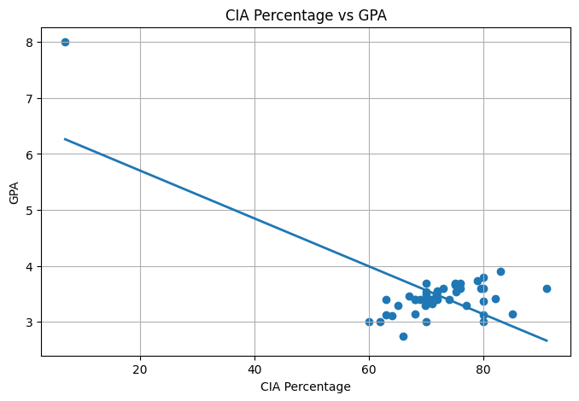
Figure: CIA Percentage vs GPA
The scatter plot shows the relationship between CIA Percentage and GPA. The regression line indicates a positive relationship between the two variables, suggesting that students with higher CIA percentages tend to achieve higher GPA values. Most students are clustered between 60%–90% CIA and GPA values between 3.0 and 4.0.
# Step 1: Save Slope and Intercept using Pickle
import pickle

parameters = {
"slope": model1.coef_[0],
"intercept": model1.intercept_
}

with open("linear_regression_weights.pkl", "wb") as file:
pickle.dump(parameters, file)

print("Parameters saved successfully.")
Parameters saved successfully.
# Step 2: Load Parameters from Pickle File
with open("linear_regression_weights.pkl", "rb") as file:
loaded_parameters = pickle.load(file)

print(loaded_parameters)
{'slope': np.float64(0.01752685626778003), 'intercept': np.float64(2.133321195068091)}
# Step 3: Use Loaded Parameters for Prediction
new_cia = 80

predicted_gpa = (
loaded_parameters["slope"] * new_cia
+ loaded_parameters["intercept"]
)

print("Predicted GPA:", predicted_gpa)
Predicted GPA: 3.5354696964904937
Parameter Saving using Pickle
The slope and intercept learned by the Linear Regression model were saved using Python's Pickle module. The parameters were stored in a file named linear_regression_weights.pkl.
The Pickle file was then loaded, and the stored parameters were retrieved successfully. Using the loaded slope and intercept values, GPA predictions were generated for new CIA percentage values without retraining the model.
This demonstrates how trained model parameters can be saved and reused for future predictions.

